PRACTICUM REPORT 12TH WEEK COMPUTER NETWORKING
Firewall Networking in Cisco Packet Tracer


Lecturer:
Dimas Novian Aditia Syahputra, S. Tr. T., M. Tr. T.
Prepared by:
Name: Aisyah Currents
NIM (Student id): 25091397108
Class: International

UNIVERSITAS NEGERI SURABAYA
FACULTY OF VOCATION
INFORMATICS MANAGEMENT STUDY PROGRAM
YEAR 2025

TABLE OF CONTENTS

TABLE OF CONTENTS 1
CHAPTER I 2
INTRODUCTION 2
1.1. Background 2
1.2. Objective 2
CHAPTER II 3
THEORETICAL BASIS 3
2.1. Firewall Functions and Types 3
2.2. Firewall Placement in Network Architecture 3
CHAPTER III 4
METHODOLOGY 4
3.1. Tools and Materials 4
3.2. Procedure 4
CHAPTER IV 8
CLOSING 8
4.1. Conclusion 8
REFERENCES 9

CHAPTER I

INTRODUCTION

Background
A firewall is a network security system that monitors, filters, and controls incoming and outgoing traffic based on predefined rules to protect internal networks from unauthorized access and cyber threats. It functions as a barrier between trusted and untrusted networks by evaluating packets, enforcing access control, and preventing malicious activities such as malware, port scanning, or exploitation attempts. Firewalls can operate in various forms, including packet-filtering, stateful inspection, proxy-based, and next-generation firewalls, each offering different levels of inspection and protection. Typically placed at the network perimeter or between network segments like the LAN, DMZ, and internet, firewalls help enforce security policies and maintain network integrity, although they must be complemented with additional security measures to provide comprehensive defense.

Objective
The objectives of this practicum are:
- Students are able to understand the basic concepts and functions of a firewall as a network security system that controls incoming and outgoing data traffic based on predefined security policies.
- Students can simulate firewall configuration using Cisco Packet Tracer to restrict access between devices or networks according to the desired security rules.
- Students are able to analyze the impact of firewall implementation on network connectivity and understand how firewalls can be used to prevent attacks and unauthorized access within a computer network environment.

CHAPTER II

THEORETICAL BASIS

2.1. Firewall Functions and Types
A firewall is a security mechanism designed to monitor, filter, and control network traffic according to predefined security rules. Its primary functions include protecting internal networks from unauthorized access, enforcing access control policies, blocking malicious traffic, and monitoring communication patterns to detect suspicious activity. Firewalls operate in several forms, the most common being packet-filtering firewalls, which examine packet headers such as IP addresses and ports; stateful inspection firewalls, which track the state of ongoing connections to make more accurate filtering decisions; and ACL-based firewalls, commonly implemented in Cisco routers using Access Control Lists that allow or deny traffic based on specific conditions. These different types of firewalls provide varying levels of security depending on network complexity and required protection.

2.2. Firewall Placement in Network Architecture
Proper firewall placement is essential to ensuring effective security within a network. Typically, firewalls are positioned at the perimeter between trusted internal networks and untrusted external networks such as the internet. They may also be placed between internal segments. For example, separating a Local Area Network (LAN), a server network, and a Demilitarized Zone (DMZ) to prevent unauthorized lateral movement and limit the impact of potential attacks. Strategic placement ensures that only permitted traffic can reach sensitive resources while potential threats are blocked early. In layered or multi-tier network environments, multiple firewalls may be deployed to create layered defenses and strengthen overall network resilience.

CHAPTER III

METHODOLOGY

3.1. Tools and Materials
The tools and materials used include:
- Laptop/PC
- Cisco Packet Tracer
Simulation Components:
1 Router
1 Server
3 PC Clients
Straight-through cable
Crossover cable

3.2. Procedure
In this experiment, we will simulate a firewall by blocking one of the client IPs using Cisco Packet Tracer. The following is the network diagram of the firewall that will be simulated.
- Make this network diagram
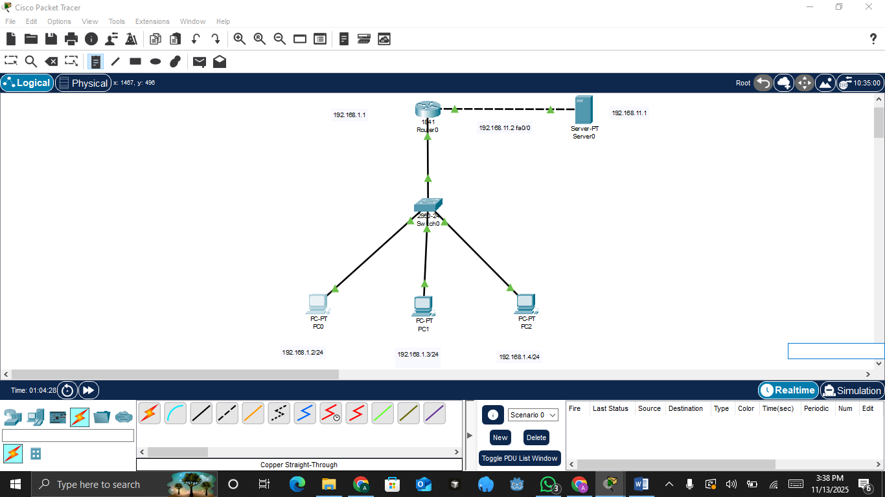
- Configurate IP address server
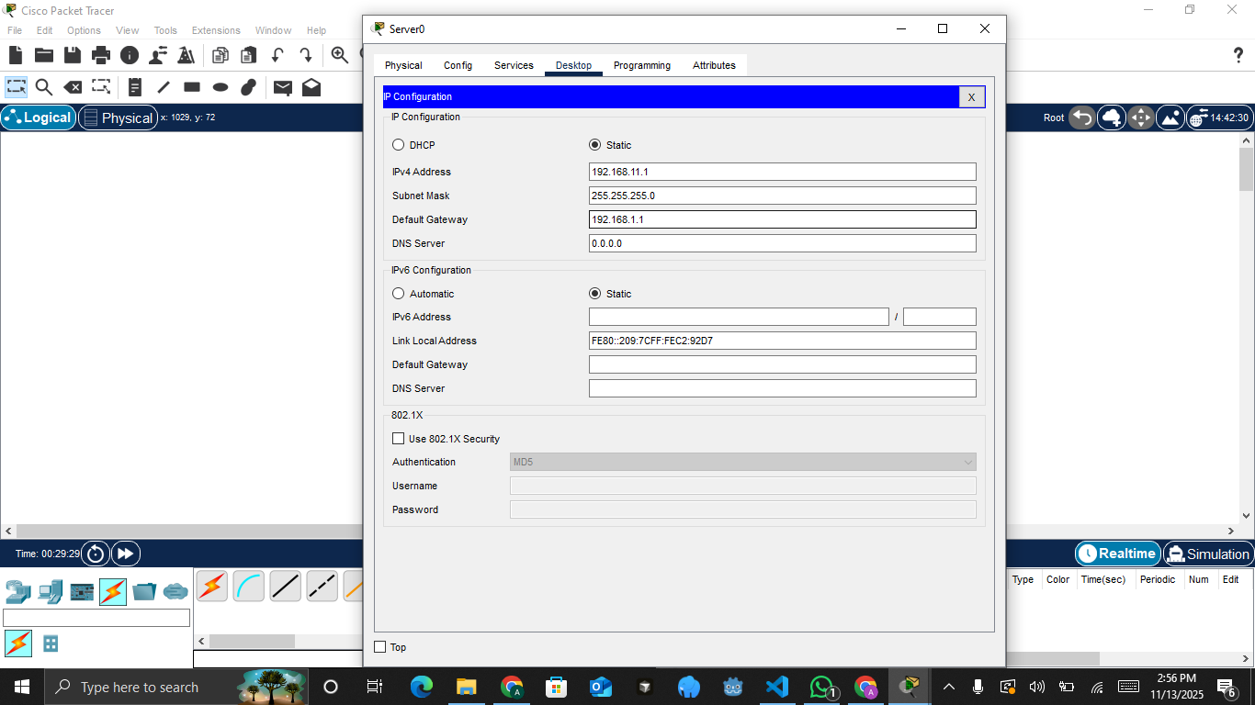
- Router configuration, On FastEthernet0/0, enter an IP address that matches the network segment in the diagram: 192.168.11.2 with subnet mask 255.255.255.0. and set the port status to On. Next, on FastEthernet0/1, enter the router's IP address 192.168.1.1 and set the port status to On.
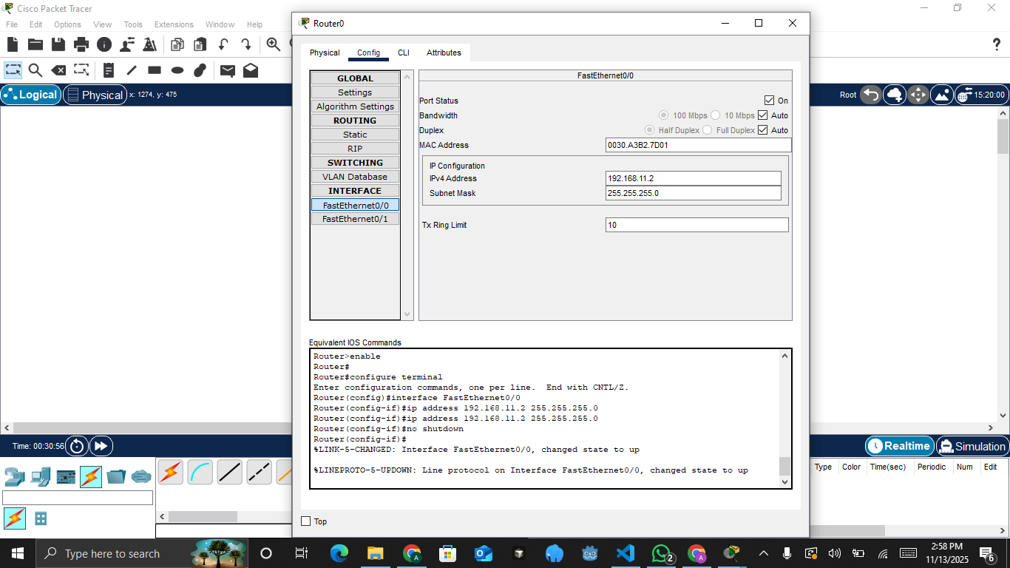
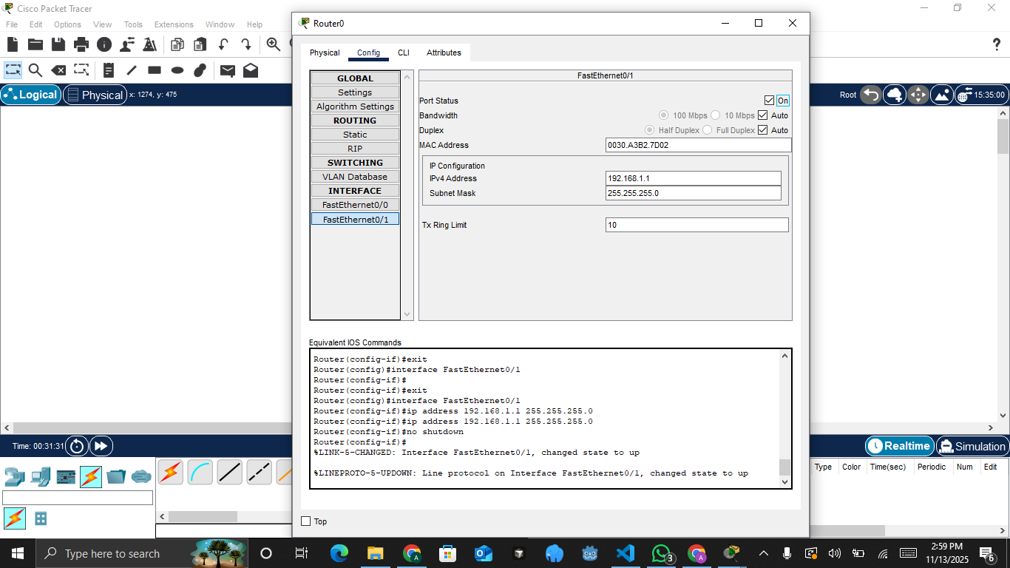
- Check the connection between the server and the router by pinging the router's IP from the server.
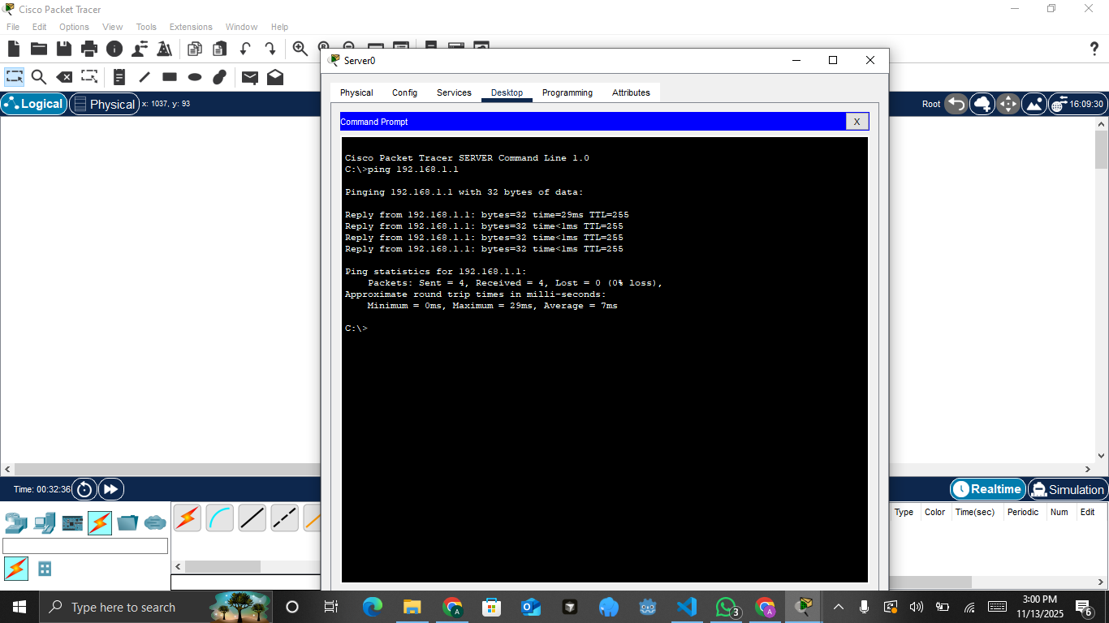
- Configure the PC with the IP address 192.168.1.2, subnet mask 255.255.255.0, and set the default gateway to the router’s IP address, 192.168.1.1. This configuration ensures that the PC can communicate with devices outside its local network through the router.
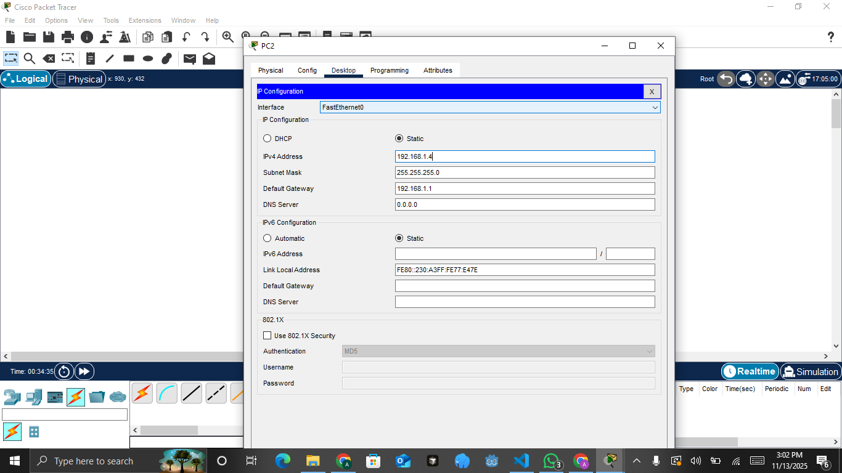
- Repeat the IP configuration on the next PCs: assign IP address 192.168.1.3 with subnet mask 255.255.255.0 and gateway 192.168.1.1 to one PC, and assign IP address 192.168.1.4 with subnet mask 255.255.255.0 and gateway 192.168.1.1 to the other PC. This ensures that all PCs are in the same network segment and can communicate through the router.
- Check the connection between one of the PCs and the server by using the ping command to verify that they can communicate within the network.
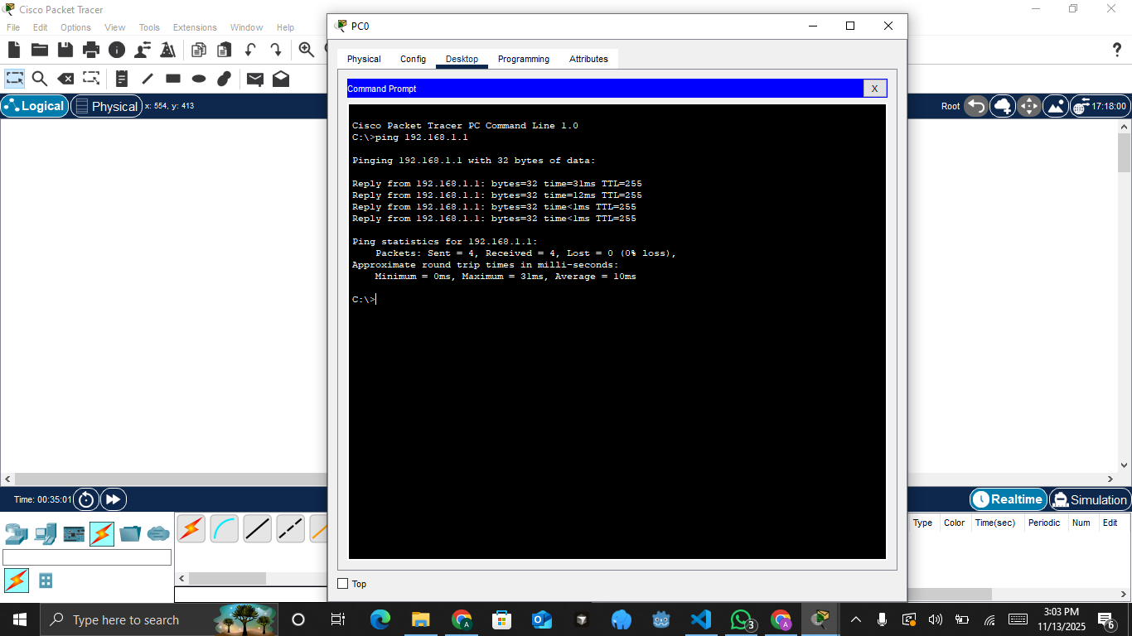
- Apply the firewall on one of the PCs. Click the router, select CLI, and then enter the following commands.
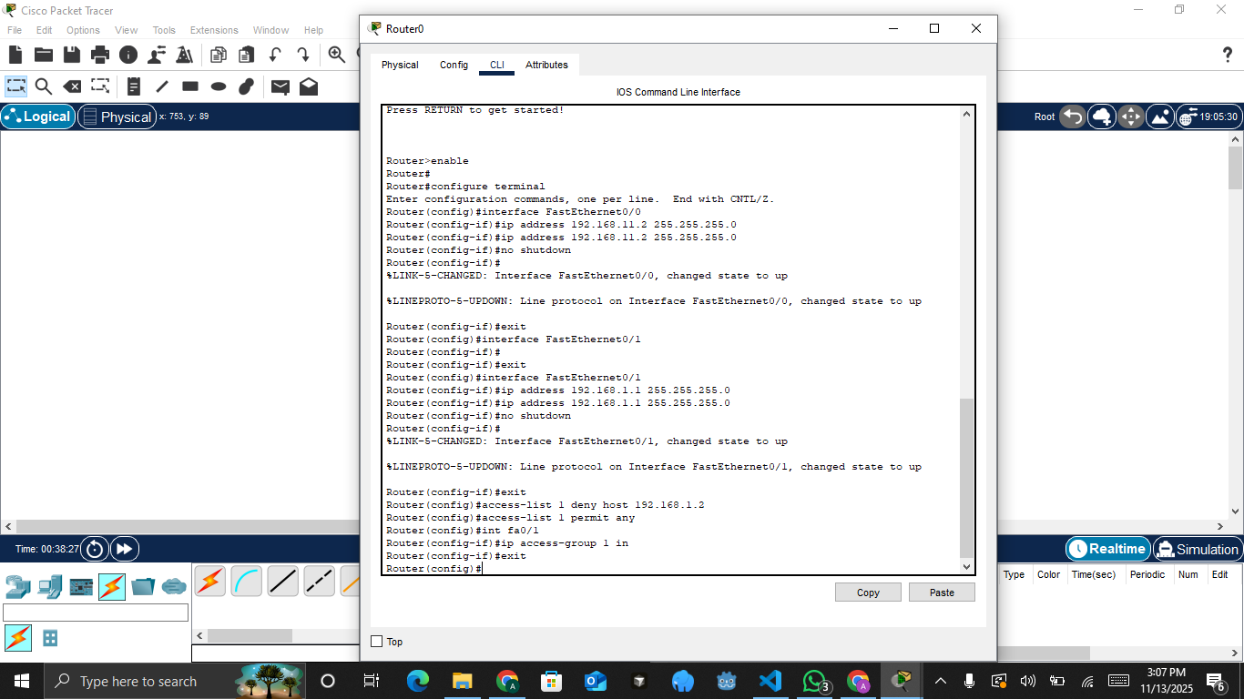
- Apply the firewall on one of the PCs. Click the router, select CLI, and then enter the following commands.
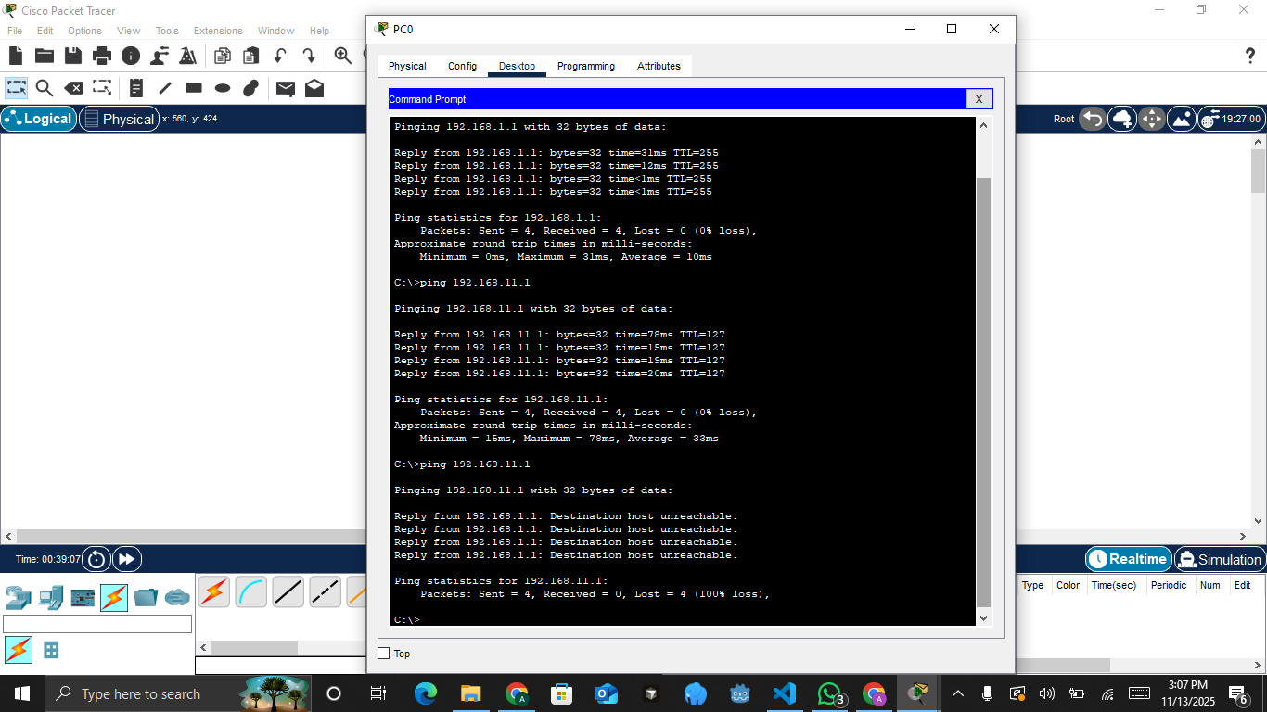

CHAPTER IV

CLOSING

4.1. Conclusion
Through this experiment, the implementation of a simple firewall using ACLs in Cisco Packet Tracer successfully demonstrated how network access can be controlled by blocking specific client IP addresses. By configuring the router, assigning proper IP addressing, and applying access-list rules, we verified that selected PCs could be denied access to the server while others remained permitted. This activity highlights the essential role of firewalls in managing network security and enforcing access policies, providing a foundational understanding of how traffic filtering works in real-world networking environments.

REFERENCES
Cisco -“What Is a Firewall?”: A definition of firewall functions and types including packet-filtering and stateful inspection.
Palo Alto Networks - “Types of Firewalls Defined and Explained”: A detailed classification of firewall types (packet filtering, proxy, NGFW, host-based, etc.)
National Institute of Standards and Technology (NIST) SP 800-41 Rev 1 -Guidelines on firewall placement within network architectures and policies.

